***Noakhali Science and Technology University***

Noakhali-3814

**Course Title** : Java & Database Management System

|  |
| --- |
| Submission Date : 16.10.2019 |

|  |  |
| --- | --- |
| Submitted to : | Submitted by : |
| Name: **Main Uddin**  **Lecturer ,**  **Depertment of** : Information & Communication Engineering  **Noakhali Science and Technology University** | Name : **Abdul Awal Nadim**  **Roll** : **ASH - 1811056M**  Year : 2, Term : 2  **Department Of :** Information & Communication Engineering  **Noakhali Science and Technology University** |

Report on : School Management System by JAVA & DBMS

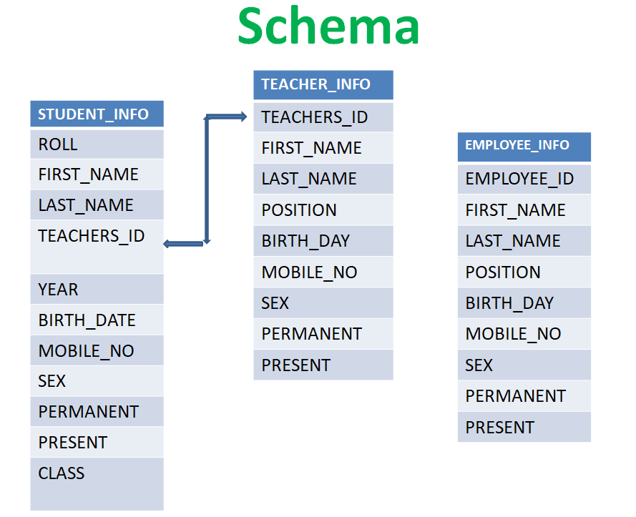

**TABLES**

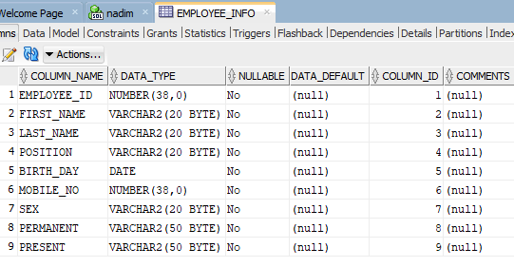

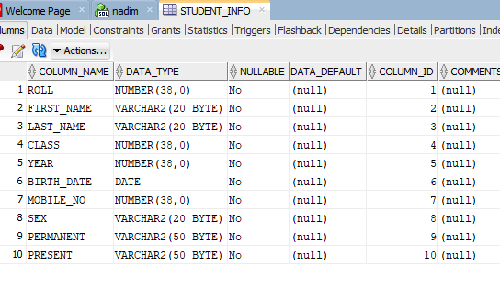

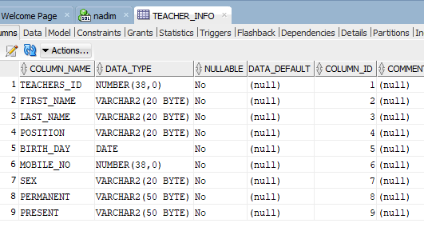

**RELATIONAL MODEL OF THE TABLES:**

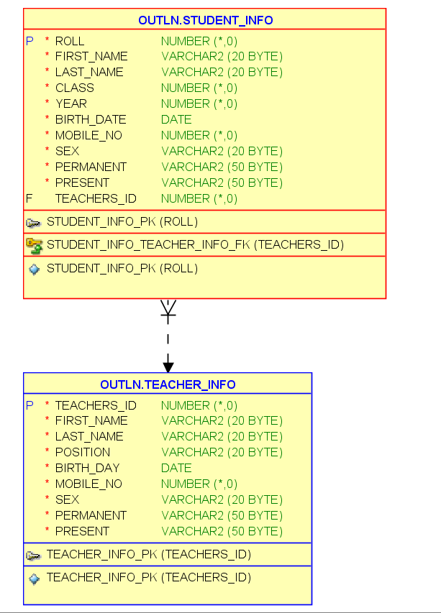

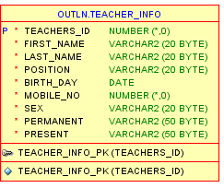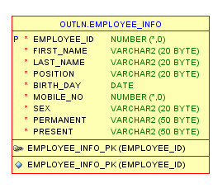

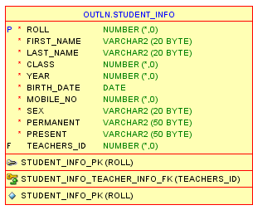

**FRAMES**

1.Login FRAM

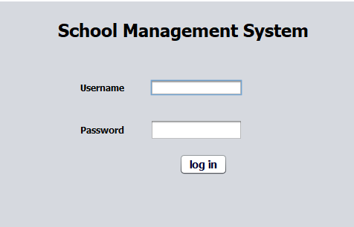

2.Home Page

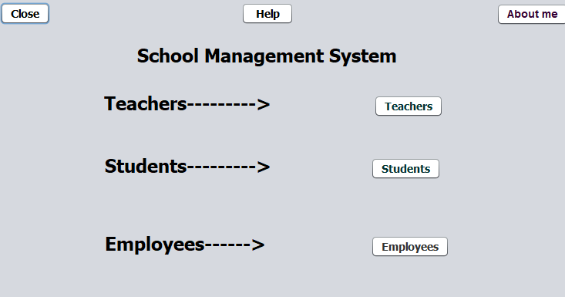

**3.Search,Insert,Update,Delete FRAM**

**a.** **Teachers Information**

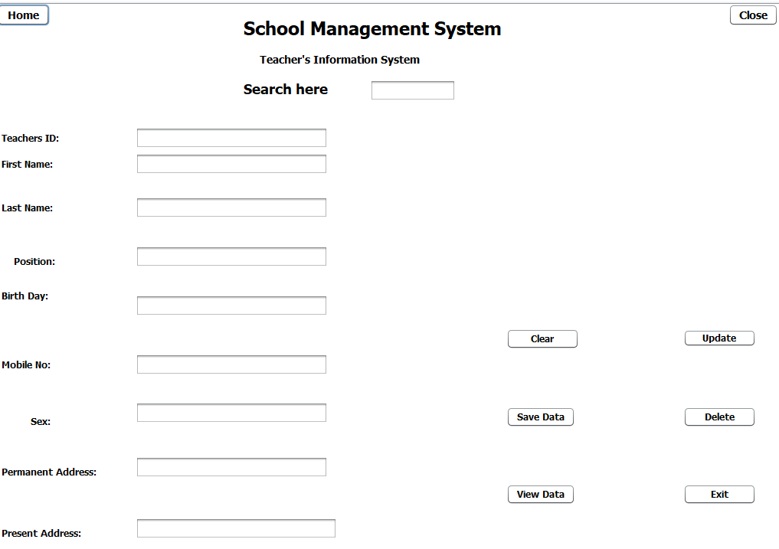

**b.Employee’s Information**

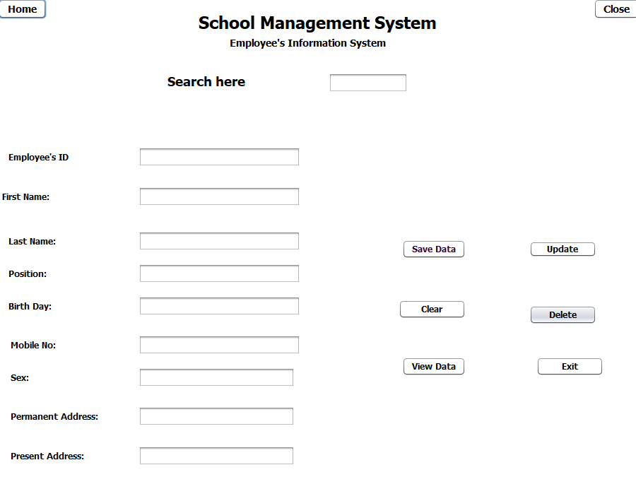

**c.Student’s Information**

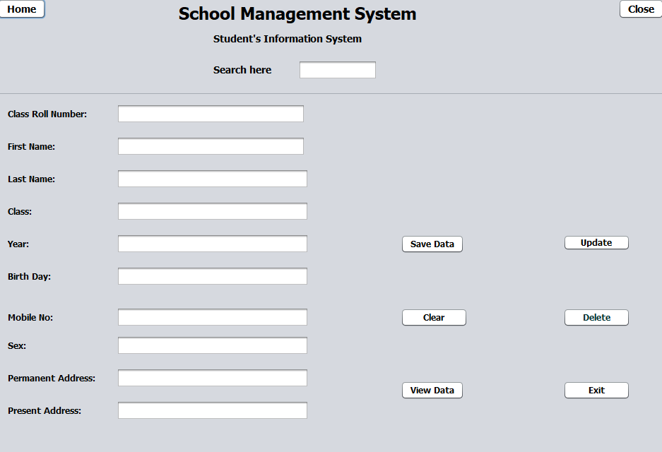

**4.Teachers DataBase**

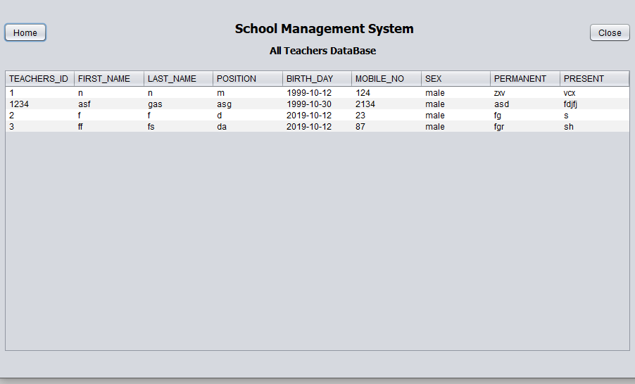

**5.Employees Database**

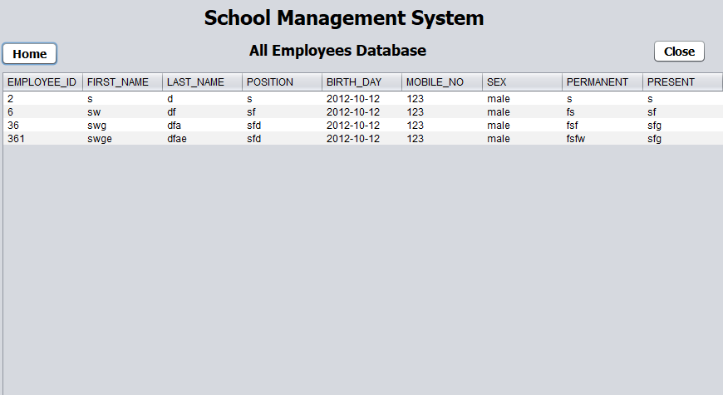

**6.** **Students Database**

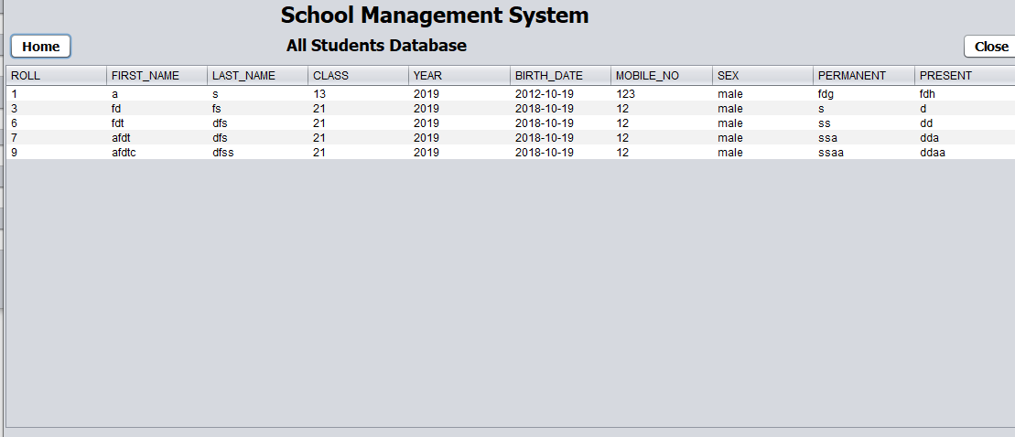

**7.Frofile**

